

$42,250

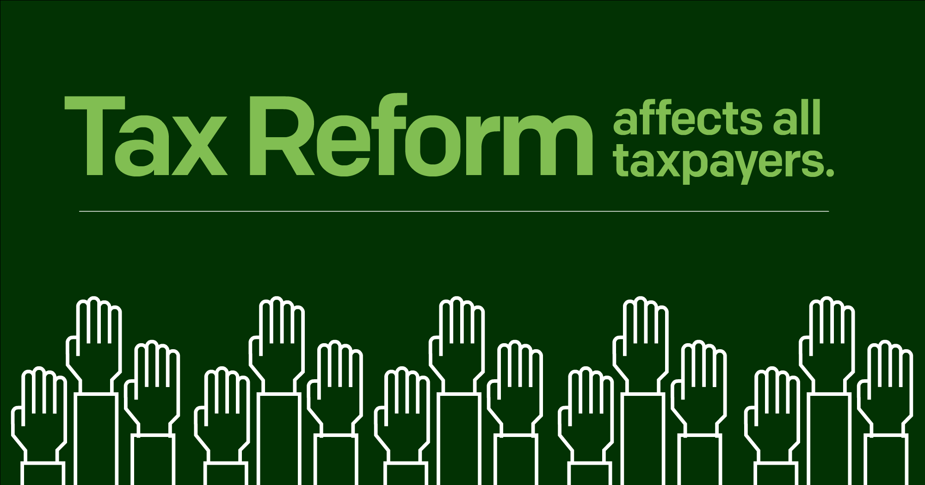

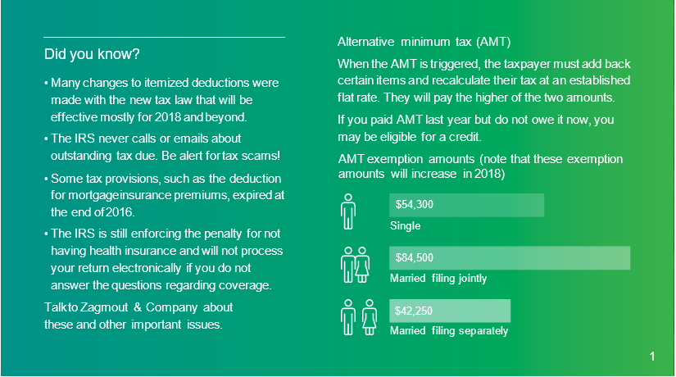

1

# Tax laws affecting higher-income taxpayers

Single filer

* Pays additional 0.9% Medicare surcharge (health insurance tax) on wages and self-employment income in excess of $200,000

Important to check

For the 0.9% additional Medicare surtax, withholding is required only on wages above $200,000. If a couple’s combined income exceeds $250,000, no Medicare surtax withholding may have taken place if each spouse earned below $200,000. This may result in under withholding (and possible penalties). Ask Zagmout & Company CPAs whether you should pay estimates.

Long-term capital gain (LTCG) rates: (note that the rates do not change for 2018, but when they apply is different)

* 10% or 15% tax bracket: 0% LTCG
* 25%, 28%, 33% or 35% tax brackets:

15% LTCG

* 39.6% tax bracket: 20% LTCG

Estate and gift tax:

* Gift tax exclusion: $14,000
* Estate tax lifetime exemption:

$5,490,000 (exemption for 2018 is about $11.2M)

* Pays additional 3.8% net investment income tax on certain income (e.g., capital gains, interest and dividend income) if modified adjusted gross income (MAGI) exceeds $200,000
* Sees itemized deductions and personal exemptions limited or completely phased out if AGI exceeds $261,500 (note that this limitation will not be in place for 2018)
* Reaches highest tax bracket of 39.6% on income over $418,400 (highest rate in 2018 is 37% for income over $500,000)

Married filing jointly

* Pays additional 0.9% Medicare surcharge (health insurance tax) on wages and self-employment income in excess of $250,000
* Pays additional 3.8% net investment income tax on certain income if MAGI exceeds $250,000
* Sees itemized deductions and personal and dependency exemptions limited or completely phased out if AGI exceeds

$313,800 (note that this limitation will not be in place for 2018)

* Reaches highest tax bracket of 39.6% on income over $470,700 (highest rate in 2018 is 37% for income over $600,000)

Married filing separately

* Pays additional 0.9% Medicare surcharge (health insurance tax) on wages and self-employment income in excess of $125,000
* Pays additional 3.8% net investment income tax on certain

income if MAGI exceeds $125,000

* Sees itemized deductions and personal and dependency exemptions limited or completely phased out if AGI exceeds

$156,900 (note that this limitation will be not be in place for 2018)

* Reaches highest tax bracket of 39.6% on income over $235,350

Head of household

 • Pays additional 0.9% Medicare surcharge (health insurance tax)

on wages and self-employment income in excess of $200,000

* Pays additional 3.8% net investment income tax on certain income if MAGI exceeds $200,000
* Sees itemized deductions and personal and dependency exemptions limited or completely phased out if AGI exceeds

$287,650 (note that this limitation will not be in place for 2018)

* Reaches highest tax bracket of 39.6% on income over $444,550 (highest rate in 2018 is 37% for income over $500,000)

## What is NIIT?

The net investment income tax (NIIT) is a 3.8% tax on a broad range of income

sources such as interest, dividends, capital gains, rental and royalty income, non- qualified annuities and passive business revenue. It affects individuals, estates and trusts above certain income levels.

2

# Tax benefits and obligations

Higher education costs

* American opportunity tax credit: up to $2,500 per eligible student for the first four years of higher education based on qualified education expenses
* Lifetime learning credit: up to $2,000 per tax return for qualified tuition and related expenses

Child and dependent care costs

* Child tax credit: provides up to $1,000 per child under 17 (increasing to $2,000 per child in 2018)
* Child and dependent care tax credit: provides a credit of 20–35% of the cost of care up to $3,000 for one or $6,000 for two or more children under age 13, or a

spouse or other dependent who is incapable of self-care

Health care and taxes — key facts for individuals and families

Under the Patient Protection and Affordable Care Act (ACA):

* If you did not have qualifying coverage for yourself or any dependents for any portion of 2017 and do not qualify for an exemption, you will be subject to a penalty when you file your federal income tax return in 2018 ($695 per uninsured adult and $347.50 per child under 18, or 2.5% of household income, whichever is higher; the penalty will be $0 beginning in 2019)
* Individuals who are within certain income limits qualify for a premium tax credit if they purchase insurance through approved market exchanges.
* Taxpayers can deduct only unreimbursed medical/ dental expenses that exceed 7.5% of adjusted gross income.

## Don’t forget FSAs or HSAs!

There are ways to reduce your taxable income by making pre-tax contributions to a flexible spending account to pay out-of-pocket medical expenses or contributing to a health savings account (HSA). Your insurance plan will determine which applies, but this provides a way to obtain a tax benefit for paying medical expenses.

Charitable tax planning

There are many tax planning opportunities related to charitable giving.

* Evaluate both tax and philanthropic goals when making contributions
* Ensure organization is qualified to receive charitable contributions ([EO Select Check](https://apps.irs.gov/app/eos/))
* Consider limitations on deductions based on the type of property and the type of organization
* Consider donating appreciated property (especially securities you are considering selling)
* Consider a donor-advised fund to help with timing/ control of contributions
* Donation for services are usually not permitted (although out-of-pocket expenses related to services rendered are normally deductible)
* Contributions specified for certain individuals are not deductible (even if the related organization is a qualified charitable organization)
* Be aware of record keeping and contemporaneous acknowledgment requirements
* Note any quid pro quo statements included on acknowledgments received
* Clothing and household items must be in good condition to receive a deduction
* For donations of property over $500, additional information may be needed for completion of Form 8283
* Remember that while generous, donations made through online fundraising sites are not tax-deductible unless the recipient is a qualified public charity.

3

# Looking forward: What can you do to minimize taxes?

Planning for ways to minimize taxes is an ongoing process. Here are some items to consider:

* Maximize your retirement plan contributions to minimize income. For tax year 2017, $18,000 (18,500 for 2018) is the limit for 401(k)s if you are under age 50; the limit is

$24,000 (24,500 for 2018) if you are age 50 or older.

* Take full advantage of employer-sponsored programs that allow you to set aside pre-tax dollars for child care or medical expenses.
* Ask Zagmout & Company CPAs whether you will likely be subject to the AMT and how to minimize the impact.
* Shift to investments that are not subject to the 3.8% net investment income tax (e.g., exempt bonds).
* Offset any capital gains by harvesting losses in your taxable brokerage account.

Zagmout & Company CPAs can advise you more on these and other strategies.

# Self-employed or own a business?

Tax planning for your business is more important than ever with the new tax law. Be sure that your books and records are in good order (or contact Zagmout & Company CPAs for bookkeeping assistance) so you can review planning opportunities.

Deduction for business income

A new deduction of potentially 20% of qualified income is available starting in 2018.

Purchases of equipment

Bonus depreciation — A deduction of 50% (or 100% if the property was acquired after Sept. 27) of the adjusted basis of qualifying property in the first year the asset is placed into service is available. The 100% deduction is available until 2022, and then the percent that can be deducted declines.

Section 179 — For tax year 2017, businesses can deduct up to $510,000 of business property (computers, office furniture, etc.) placed in service during the tax year.

Starting in 2018, the deduction available is $1,000,000 and the new tax law expands the qualified property to include certain improvements to commercial real property.

Retirement plans

Consider establishing a qualified retirement plan, such as:

* SEP IRA: May contribute up to the lesser of 25% of net income or $54,000
* 401(k): Employee deferral plan, plus profit sharing component

Affordable Care Act (ACA)

Rules for reporting health insurance coverage to the IRS are in effect and penalties for failing to do so can be steep. ACA information returns for tax year 2017 are due to employees by March 2 (a 30-day extension from original Jan. 31 due date) and to the IRS by Feb. 28; April 2 if filed electronically.

The Small Business Health Care Tax Credit, which is 50% for small employers and 35% for small tax-exempt

employers may help offset costs but is subject to several restrictions. It can be claimed only:

* If the employer has fewer than 25 full-time equivalent employees
* If the employer pays more than 50% of employees’ premium costs.
* If the employer’s average salary is $50,000 or less
* If the employer offers coverage through the SHOP Marketplace

4